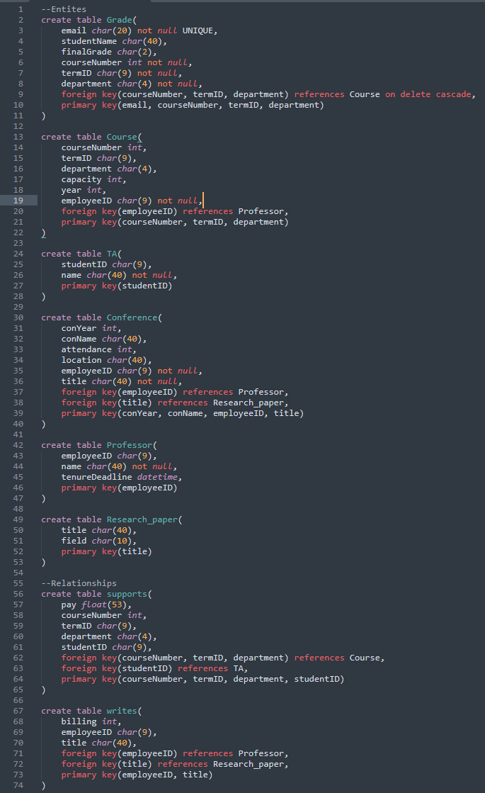

1. 𝜋firstName, lastName(σbirthDate < 1994-5-1 ^ income > 94000(Customer))
2. 𝜋customerID, lastName, birthDate(((σbudget > 2300000(Branch)⨝Account)⨝Owns)⨝Customer)
3. 𝜋sin, firstName, lastName((Employee⨝PersonalBanker)⨝Branch)
4. 𝜋Owns.customerID, copy.customerID, Owns.accNumber(σOwns.accNumber = copy.accNumber ^ Owns.customerID != copy.customerID(Owns X ρcopy(Owns)))
5. 𝜋employee.sin,employee.salary( σemployee.salary > m.salary(𝜋branchNumber, managerSin(Branch) ⨝ (Employee X ρm(Employee))) )
6. 𝜋branchName( Branch ⨝ (σemployee.branchNumber = d.branchNumber(σlastName = ‘Wilson’(Employee) X ρd(σlastName = ‘Carson’(Employee)))) )
7. 𝜋firstName, lastName, birthDate(σbranchName = ‘Lonsdale’(((Customer ⨝ Owns) ⨝ Account) ⨝ Branch)) ∪ 𝜋firstName, lastName, startDate(σbranchName = ‘Lonsdale’(Employee ⨝ Branch))
8. 𝜋customerID, birthDate(σbranchName = ‘Kitsilano’ V branchName = ‘Marine’((PersonalBanker ⨝ Employee) ⨝ Branch) ⨝ σbranchName = ‘Kitsilano’ V branchName = ‘Marine’((PersonalBanker ⨝ Employee) ⨝ Branch))
9. 𝜋customerID(σamount >= 20000 V amount <= -20000((Customer ⨝ Owns) ⨝ Transaction))
10. 𝜋customeID, income( ((Customer ⨝ Owns) ⨝ Account) ÷ 𝜋type(Account))
11. 𝜋employee.sin, employee.firstName, employee.lastName(σd.firstName = employee.firstName ^ d.lastName = employee.lastName ^ d.branchNumber = employee.branchNumber(ρd(𝜋firstName, lastName, branchNumber((Customer ⨝ Owns) ⨝ Account)) X 𝜋sin, firstName, lastName, branchNumber(Employee)))
    1. This query does not match the desired data, however it does come close to it. This is because there is no restriction saying the first and last names of employees cannot be the same as customers. The closest I can relate the two is that both the account and employee work at the same branch number(unique), and if they both have the same first and last names, we assume they’re the same person.
12. {t | ∃s ϵ Customers(s.birthDate < 1994-5-1 ^ s.income > 94000 ^ t.firstName = s.firstName ^ t.lastName = s.lastName)}
13. {t | ∃s ϵ Employee ∃p ϵ PersonalBanker ∃b ϵ Branch(s.sin = t.sin ^ s.firstName = t.firstName ^ s.lastName = t.lastName ^ s.sin = p.sin ^ s.branchBumber = b.branchNumber}